Day 27
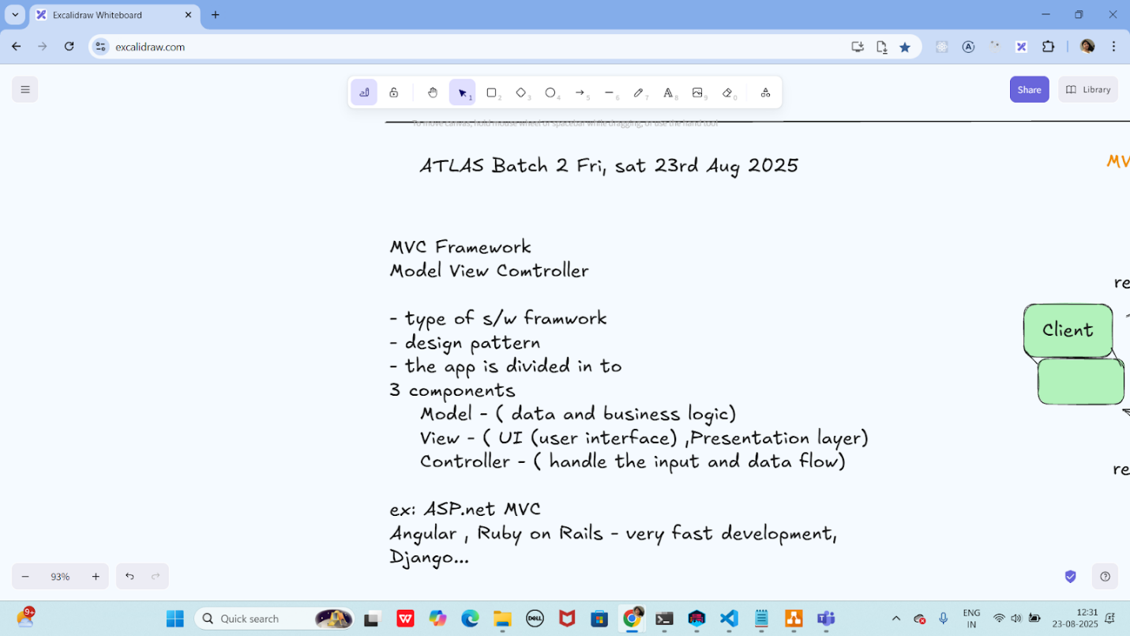

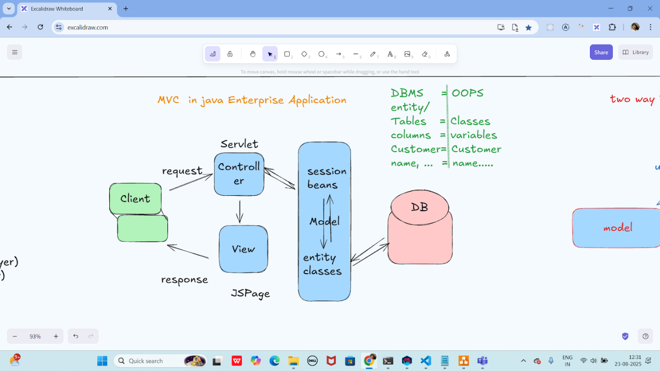

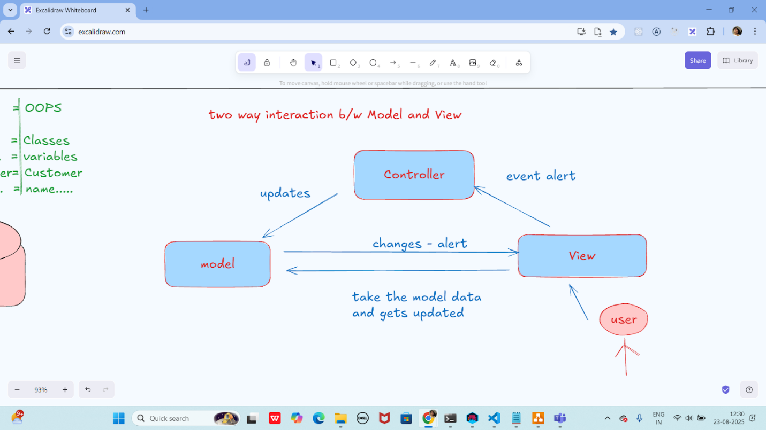

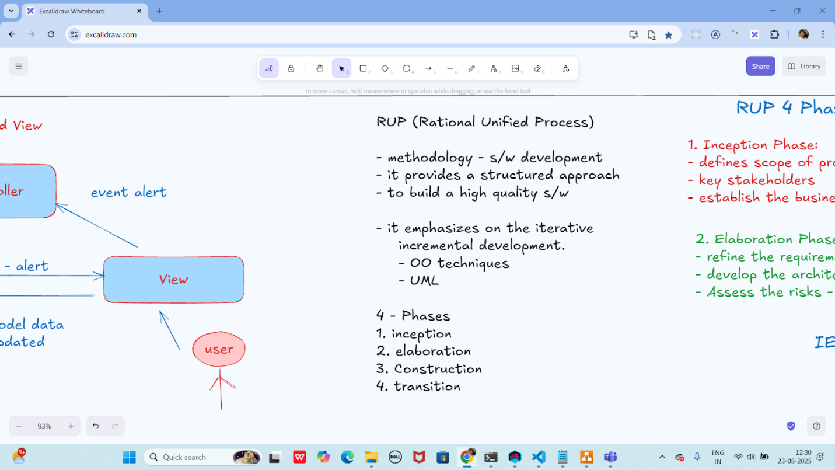

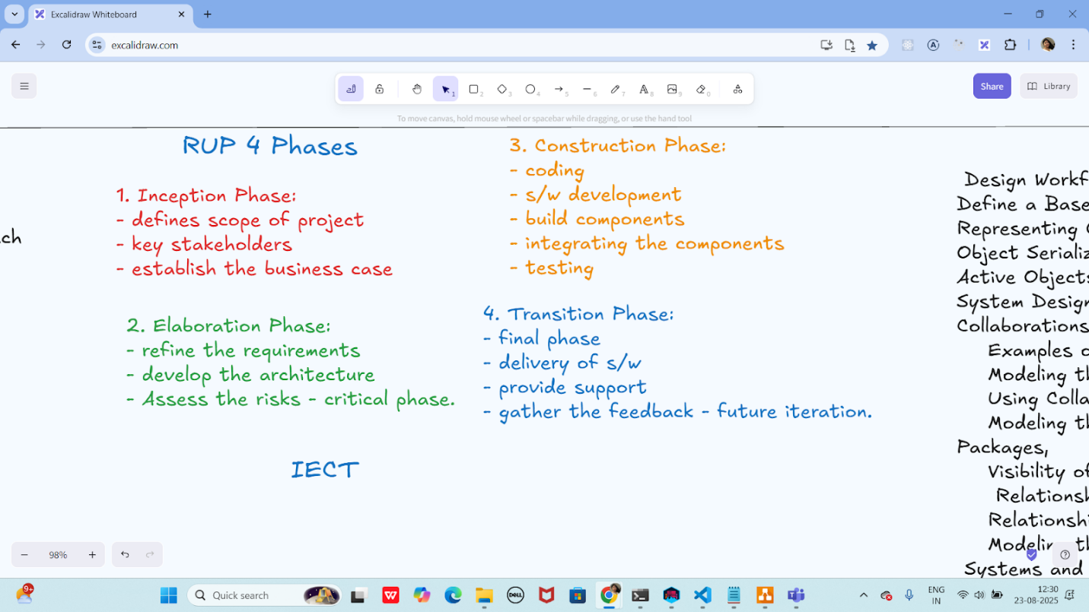

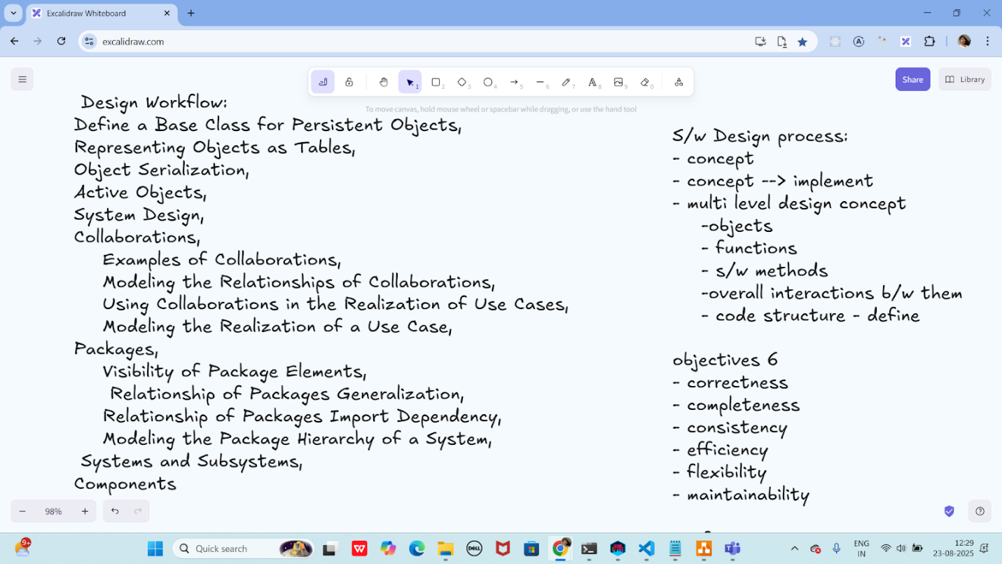

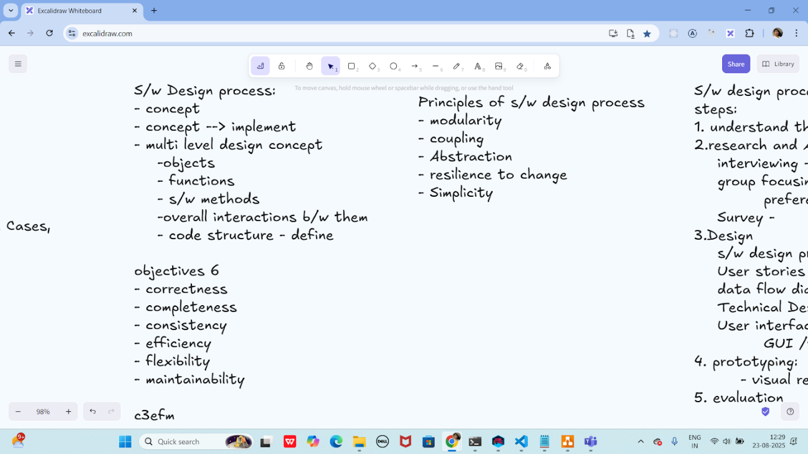

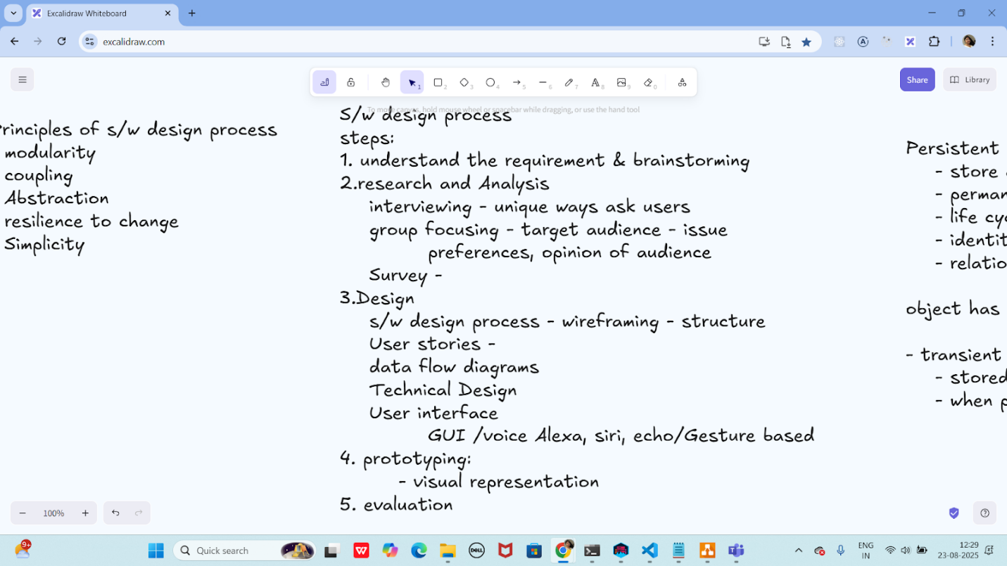

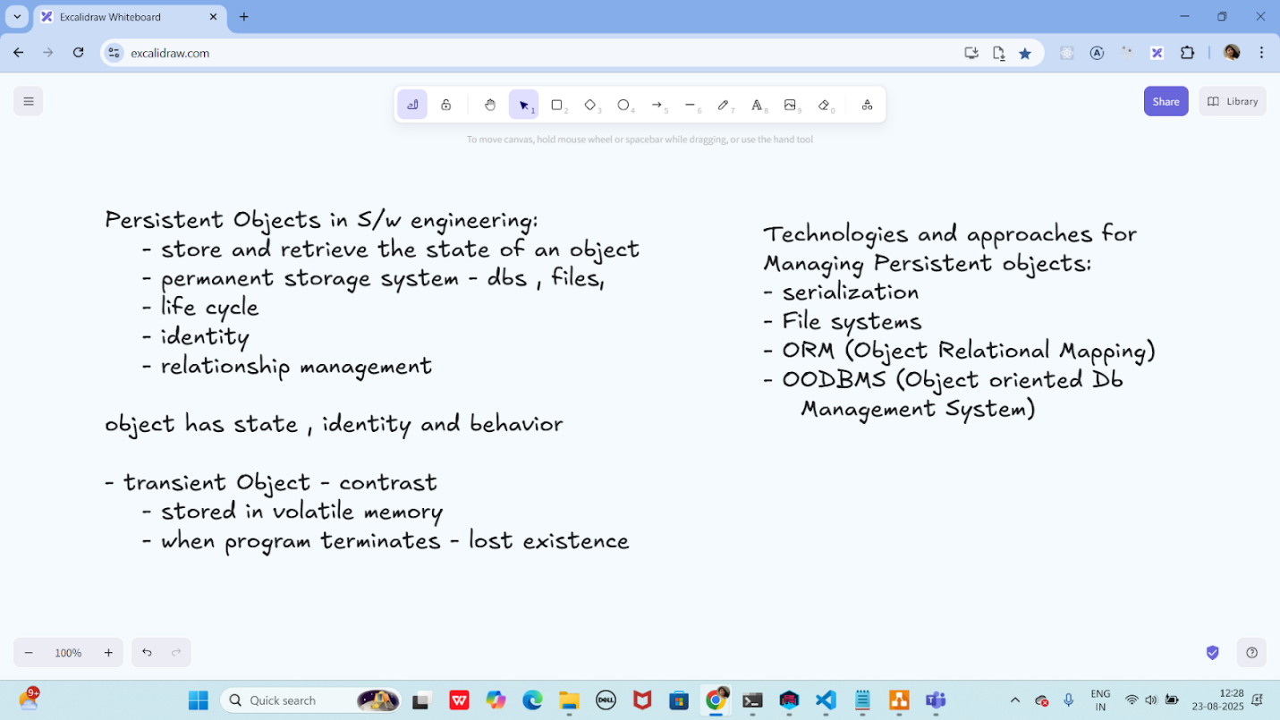

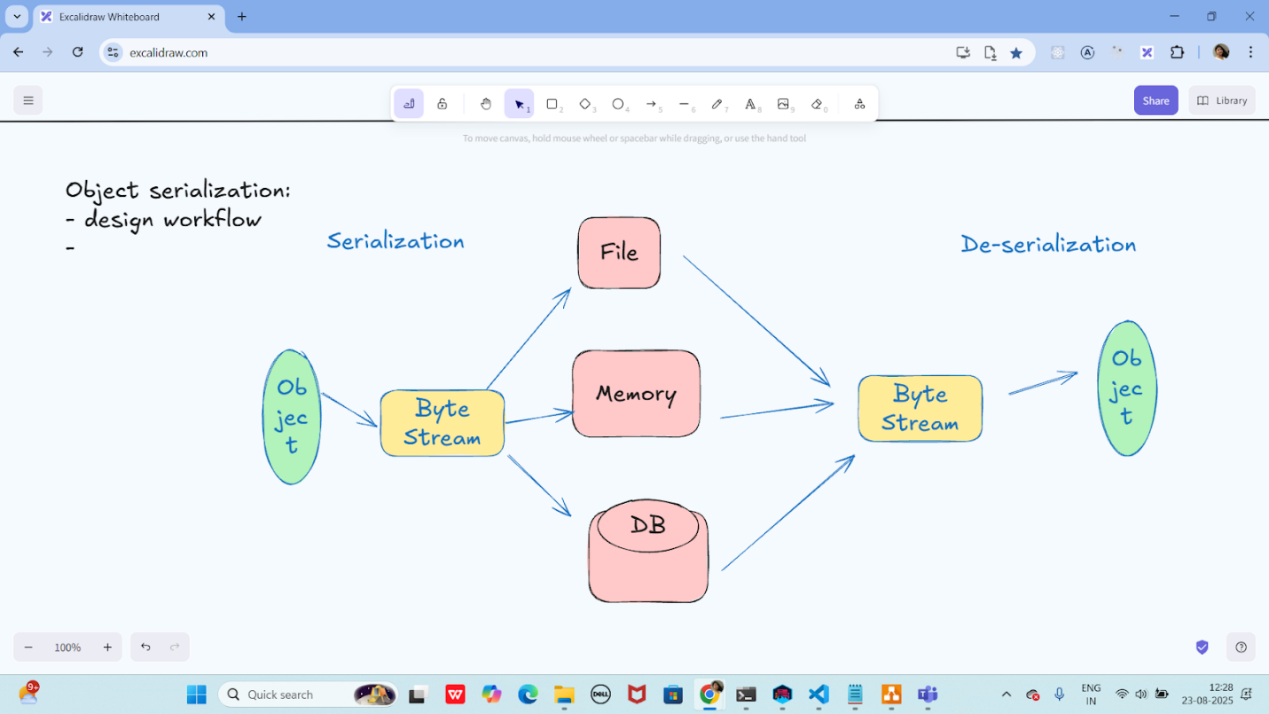

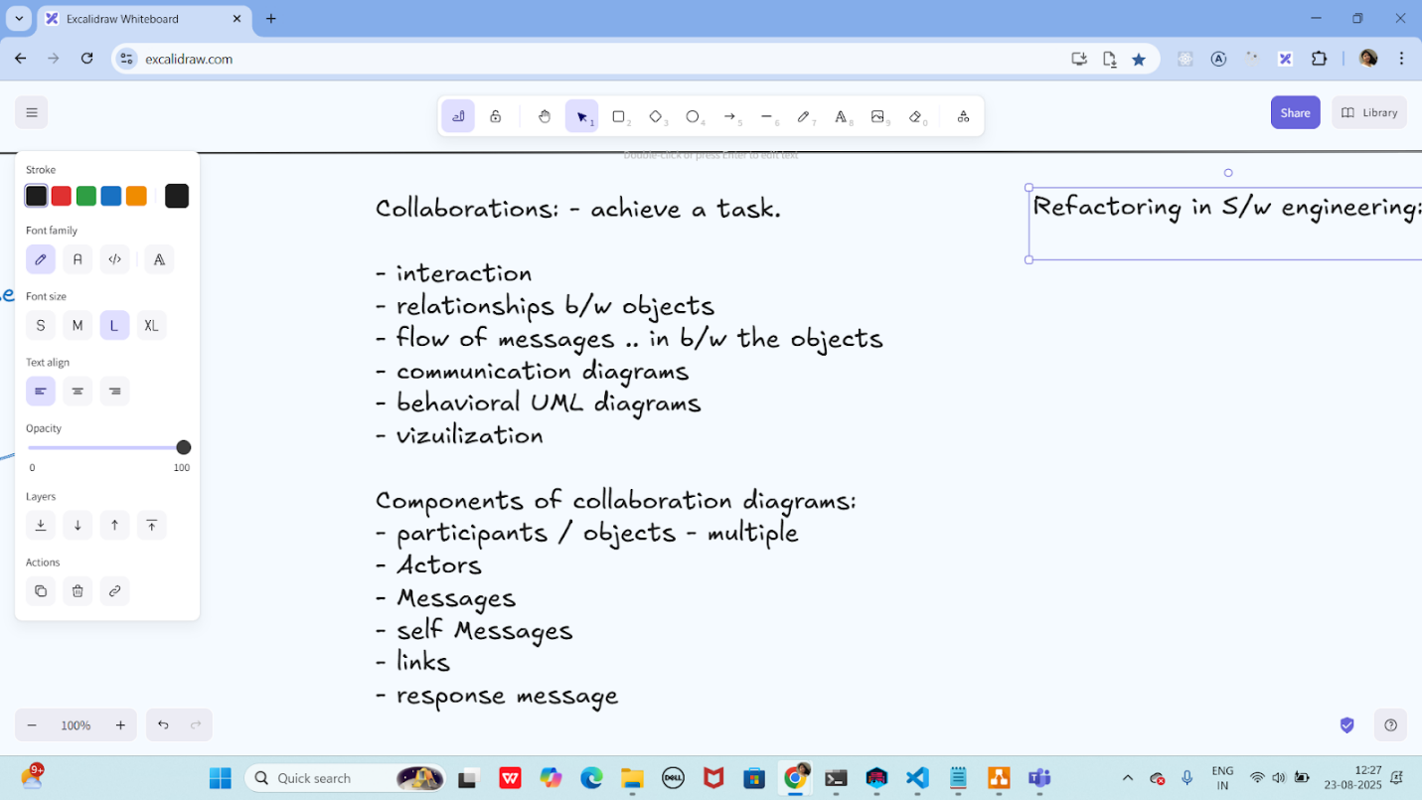
Task 1:
What do you think is the need for Refactoring?
Refactoring is the process of restructuring existing computer code without changing its external behavior, to improve its internal structure, readability, and maintainability. The need for refactoring arises from several factors:
Reasons for Refactoring:
- Improved Code Readability: Refactoring helps to make the code more readable, understandable, and maintainable by simplifying complex logic, renaming variables, and improving code organization.
- Reduced Technical Debt: Technical debt refers to the cost of implementing quick fixes or workarounds that need to be revisited later. Refactoring helps to reduce technical debt by improving the code's internal structure and eliminating unnecessary complexity.
- Enhanced Code Quality: Refactoring improves the overall quality of the code by eliminating bugs, reducing duplication, and improving performance.
- Easier Maintenance and Evolution: Refactored code is easier to maintain and evolve over time, as it is more modular, flexible, and adaptable to changing requirements.
- Improved Scalability: Refactoring can help improve the scalability of the code by reducing bottlenecks, improving performance, and making it easier to add new features.
- Better Code Reusability: Refactored code is more modular and reusable, making it easier to apply in different contexts and reducing code duplication.
Task 2:
What are the Principles of refactoring?
Principles of Refactoring:
- Test-Driven Refactoring: Refactor code in small steps, and thoroughly test each step to ensure that the code still behaves as expected.
- Small, Incremental Changes: Make small, incremental changes to the code, rather than trying to make large, sweeping changes.
- Preserve Behavior: Ensure that the refactored code preserves the same behavior as the original code.
- Improve Structure: Improve the internal structure of the code, such as by reducing coupling, improving cohesion, and eliminating unnecessary complexity.
- Simplify Code: Simplify code by eliminating unnecessary complexity, reducing duplication, and improving readability.
- Improve Readability: Improve the readability of the code by using clear and concise naming conventions, comments, and formatting.
- Reduce Coupling: Reduce coupling between different parts of the code, such as by using interfaces, abstraction, and encapsulation.
- Improve Cohesion: Improve cohesion within individual parts of the code, such as by ensuring that each module or function has a single, well-defined responsibility.
Task 3:
What are the steps for performing code refactoring?
Steps for Code Refactoring:
- Identify the Need for Refactoring: Determine which parts of the code need refactoring, such as areas with high complexity, duplication, or technical debt.
- Set Clear Goals: Define the goals of the refactoring effort, such as improving code readability, reducing complexity, or improving performance.
- Write Automated Tests: Write automated tests to ensure that the refactored code behaves as expected and to catch any regressions.
- Choose a Refactoring Technique: Select a suitable refactoring technique, such as renaming variables, extracting methods, or simplifying conditional statements.
- Apply the Refactoring: Apply the chosen refactoring technique to the code, making small, incremental changes.
- Run Automated Tests: Run automated tests after each refactoring step to ensure that the code still behaves as expected.
- Review and Refine: Review the refactored code and refine it further if necessary, ensuring that it meets the desired goals and standards.
- Document Changes: Document the changes made during refactoring, including any changes to the code's structure, functionality, or performance.
Task 4:

What makes Composite pattern useful when designing complex tree structures?
- It replaces the use of collections to store children
- allows treating individual objects and compositions uniformly through a common interface.
- It automatically serializes tree objects for persistence
- optimizes memory by removing duplicate nodes in the tree

Task 5:

Identify the code smell:
public class Order {
private String orderid;
private String customerName;
private String customerAddress;
private String customerPhone;

public String getOrderld() {
return orderid,
}

public void setOrderld(String orderid) {
this.orderid orderid,
}
public String getCustomerName() {
return customerName;
}
public void setCustomerName(String customerName) {
this.customerName = customerName;
}
public String getCustomerAddress() {
return customerAddress;
}
public void setCustomerAddress(String customerAddress) {
this.customerAddress = customerAddress;
}
public String getCustomerPhone() {
return customerPhone;
}
public void setCustomerPhone(String customerPhone) {
this.customerPhone = customerPhone;
}
}

- Long Method
- Primitive Obsession
- Large Class
- Feature Envy

Task 6:
In the context of the Three-tier architecture, what role does the 'Business Logic Layer play?
- It is responsible for managing physical data storage and retrieval mechanisms from database systems.
- It processes commands from the user interface, performs validations, and implements te core functional Logic.
- It defines how the system behaves under network traffic and handles load balancing
- it renders the UI elements and sends them directly to database procedures for execution

Task 7:

What is the role of Packages in representing subsystems?
- Packages are used only to store deprecated classes for backward compatibility
- Packages group related elements and can be used to modularize large systems into manageable subsystems with defined interfaces
- Packages represent reusable libraries only and are not part of design architecture
- Packages define the runtime performance model of subsystems

Task 8:
You are building a system that maintains a cache of user sessions. The session data must be accessed globally and initialized once, lazily. Which implementation is the most thread-safe and efficient?
public class SCache {
private static volatile SCache instance;
private SCache() {}
public static SCache getinstance() {
if (instance == null) {
synchronized (SCache.class) {
if (instance == null) {
instance = new SCache();
}
}
}
return instance;
}
}
- Implements Command pattern for caching logic
- Uses double checked locking Singleton, ensures lazy and thread-safe initialization
- Applies Factory pattern with static holder
- Uses Prototype pattern with unnecessary locking

Task 9
Identify the code smell :
public class Customer {
private String name;
private String address;
private String phoneNumber;
public void printCustomer Details() {
System.out.println("Name: " + name);
System.out.println("Address: " + address);
System.out.println("Phone Number: " + phoneNumber);
}
}

- Long Method
- Primitive Obsession
- Large Class
- Feature Envy

Task 10:

Consider the following set of interfaces and classes for a payment system. What principle is violated and how would you improve it?

interface PaymentService{
void makePayment();
void cancelPayment();
void generatelnvoice();
}

class CreditCardPayment implements PaymentService {
@Override
public void makePayment() {
Implementation for making credit card payment
}

@Override
public void cancelPayment() {
//Implementation for canceling credit card payment
}

@Override
public void generatelnvoice() {
// Not applicable for credit card
}
}
- Liskov Substitution Principle is violated due to missing default behavior
- Dependency Inversion is violated, introduce abstraction for the payment handler
- Open Closed Principle is violated by not supporting extension for other payment types
- Interface Segregation Principle is violated spit the interface into more specific ones for better adherence to roles.

Task 11:
Consider the following class hierarchy. What major design issue exists and how would you refactor it?
class Notification {
public void send(String message) {
System.out.println("Sending generic notification: message);
}
}

class EmailNotification extends Notification }
@Override
public void send(String message) }
System.out.println("Sending email:+message);
}
}

class SMSNotification extends Notification {
@Override
public void send(String message) {
throw new Unsupported OperationException("SMS not supported");
}
}
1. Violates Interface Segregation, merge all notifications into one abstract class
2. Violates Liskov Substitution Principle: use interfaces and split behaviors per notification type
3. No issue, the design is extensible and allows overriding
4. Follows Open-Closed Principle; hence no refactoring is needed

Task 12

What is a key benefit of using the Facade design pattern in application architecture?

- It provides a way to eliminate middle layers and reduce abstraction in software components.
- It allows access to the low level subsystems directly for debugging and testing
- It offers a mechanism for injecting multiple implementations into a core algorithm dynamically
- It simplifies access to a complex system by providing a unified interface over a set of interfaces in a subsystem

Task 13:

How does the Proxy Design Pattern support performance or access control?
- It executes logic inside core components without any delegation.
- It logs method calls without executing them.
- It provides a placeholder to control access to another object, often adding lazy loading, access control, or caching.
- It permanently replaces the original object with a faster mock implementation

Task 14:

Which of the following best represents the "Open/Closed Principle from the SOLID principles?
- Software components should be designed to be open for direct modification but closed to extension for maintaining rigidity
- Entities should be open for extension through mechanisms like inheritance or composition, but closed for modification to avoid breaking existing behavior
- Code should be able to accept runtime parameter changes without altering any class behavior or interface
- Code must be completely static to avoid any modification or future maintenance overhead

Task 15:
What distinguishes the Builder pattern from the Prototype pattern in object creation?
- The Builder pattern focuses on shallow copying of objects while Prototype deals with constructing complex objects step by step
- The Builder pattern separates the construction of a complex object from its representation, while Prototype allows creation of duplicate objects by copying an existing one
- The Builder pattern helps clone objects quickly whereas Prototype builds objects using various helper methods
- The Builder and Prototype serve similar purposes but Builder is used at compile time and Prototype at runtime

Task 16:
You've joined a legacy insurance product where changes in one module often result in failures in unrelated modules. There's a lack of clear ownership and multiple responsibilities per class. You're tasked with improving stability and maintainability without breaking functionality. What is the first approach you should take?

- Merge related classes into one for tighter control
- Rewrite all modules from scratch using latest Java frameworks
- Refactor classes to follow the Single Responsibility Principle and identify code smells
- Move business logic to the frontend to reduce complexity in backend

Task 17:
Analyze the code below. What anti-pattern or refactoring opportunity is present here?
class UserManager {
public void processUser(String username) {
if (username.equals("admin")) {
// Admin-specific logic
}else if (username.equals("guest")) {
// Guest-specific logic
} else {
// Default logic
}
}
- The method violates the Open Closed Principle, consider using polymorphism instead of hard-coded conditions
- No refactoring is required since all roles are covered
- The method property uses polymorphism by branching based on user roles
- The logic should be moved to the database to improve separation of concerns

Task 18:
You're designing a microservice-based inventory system where changes in product details should notify multiple services like pricing, recommendation, and search. These dependent services should act independently and not affect the source servicer's behavior. How should you model this behavior?
- Use a centralized database to keep all services in sync
- implement direct service-to-service RPC calls on update
- Use asynchronous messaging with Publish Subscribe to notify downstream services
- Add retry logic in all dependent services for error recovery

Task 19:
A logistics company's platform must scale to millions of requests per day. The design should separate data handling, business logic, and presentation, allowing independent scaling of layers. Which architectural model should be applied?
- Use Decorator to wrap all business logic for better scaling
- Use a 3-tier Architecture to decouple UI, Business, and Data layers
- Implement Singleton in each layer to reduce memory usage
- Implement Proxy classes to replace all direct DB interactions

Task 20:
What characteristic of a well-written unit test makes it valuable in Test Driven Development?
- It should test only one method but involve multiple objects and rely on external systems.
- It must execute complex test scenarios using mock networks and full integrations
- It should be independent of the code and unrelated to the software behavior
- It should be repeatable, focused on a single responsibility and clearly define expected outcomes for each condition

Task 21:
A project has high unit test coverage but frequent production bugs. On investigation, the tests mostly validate getters, setters, and trivial logic. How can the test suite be improved to catch real-world issues?
- Add more assertions to the existing tests without changing test focus
- Refactor tests to coverage cases, boundary conditions, and business logic paths
- Migrate unit tests to performance tests
- Replace unit tests with mocks to simulate data better

Task 22:
A team is building a financial analytics platform where data needs to be fetched from multiple sources like APIs, files, and databases. These sources require different logic but return results in a similar format. The lead architect wants to design it in a way that supports adding new data sources in the future without modifying the core system. What pattern is most appropriate?
- Use Singleton to manage shared resource access to these sources
- Use Strategy Pattern to encapsulate source specific logic and switch at runtime
- Use Prototype to clone existing logic for each data source
- Use Decorator Patten to layer additional features on top of each data source

Task 23:
While working on a distributed messaging system, a team is facing challenges with tightly coupled modules. The event producers and consumers are directly referencing each other, causing deploy-time dependencies. What design adjustment would decouple them efficiently?
- Introduce direct REST calls instead of asynchronous messaging
- Use the Publish Subscribe Pattern to decouple producers from consumers
- Add shared database access between both modules
- Use Adapter Pattern to hide implementation details
Taks 24:
LargeScale Systems:
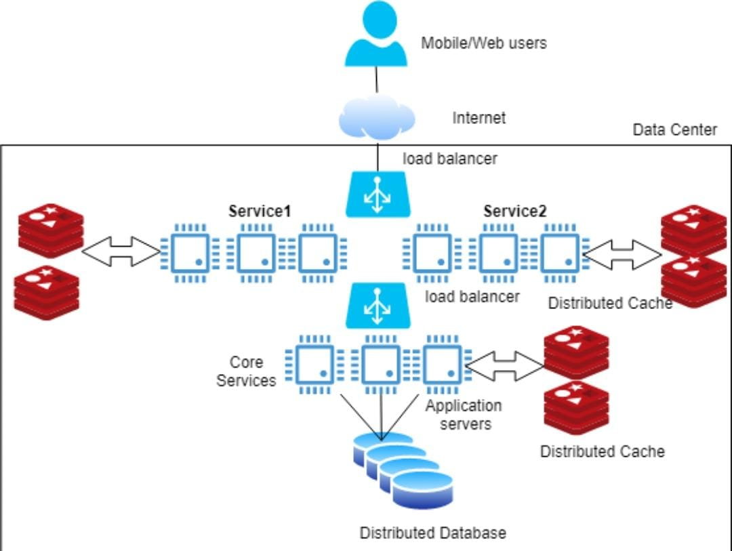

Debate:
- Large-scale systems
Large-scale systems are complex software systems that are designed to handle a large volume of users, data, and transactions. These systems are typically characterized by:
Key Characteristics:
- High Scalability: The ability to handle increasing traffic, data, and user growth without significant performance degradation.
- High Availability: The system is designed to be always available, with minimal downtime, and can recover quickly from failures.
- Distributed Architecture: The system is composed of multiple components, services, or nodes that work together to provide the overall functionality.
- Complexity: Large-scale systems often involve complex interactions between multiple components, services, and stakeholders.
- Large User Base: The system is designed to support a large number of users, often with diverse needs and requirements.
Examples:
- Social Media Platforms: Facebook, Twitter, Instagram
- E-commerce Platforms: Amazon, eBay, Walmart
- Online Banking and Payment Systems: PayPal, Stripe, Bank of America
- Cloud Computing Platforms: AWS, Azure, Google Cloud
- Search Engines: Google, Bing
Challenges:
- Scalability: Handling increasing traffic and data without performance degradation.
- Reliability: Ensuring the system is always available and can recover from failures.
- Security: Protecting user data and preventing unauthorized access.
- Complexity Management: Managing the complexity of the system and ensuring that it is maintainable.
- Performance Optimization: Optimizing the system for performance, latency, and throughput.
Design Principles:
- Microservices Architecture: Breaking down the system into smaller, independent services.
- Service-Oriented Architecture: Designing services that can be reused and composed.
- Distributed Systems: Designing systems that can scale horizontally and handle failures.
- Caching: Using caching to improve performance and reduce latency.
- Monitoring and Logging: Monitoring and logging to detect issues and improve system reliability.
Large-scale systems require careful design, planning, and execution to ensure that they meet the needs of their users and stakeholders
- Load Balancers:
Load balancers are devices or software that distribute incoming network traffic across multiple servers to improve responsiveness, reliability, and scalability of applications. They play a crucial role in ensuring that no single server becomes overwhelmed and becomes a single point of failure.
Key Benefits:
- Improved Scalability: Load balancers allow you to add or remove servers as needed to handle changes in traffic.
- Increased Reliability: By distributing traffic across multiple servers, load balancers can help ensure that your application remains available even if one or more servers fail.
- Enhanced Performance: Load balancers can improve responsiveness by directing traffic to the most available server.
- Session Persistence: Load balancers can ensure that a user's session is persisted across multiple requests.
Types of Load Balancers:
- Hardware Load Balancers: Physical devices specifically designed for load balancing.
- Software Load Balancers: Programs that run on standard servers and perform load balancing.
- Cloud Load Balancers: Load balancing services provided by cloud providers.
Load Balancing Algorithms:
- Round-Robin: Each incoming request is sent to the next available server in a sequence.
- Least Connection: Incoming requests are sent to the server with the fewest active connections.
- IP Hash: Each client's IP address is hashed to determine which server to send the request to.
Use Cases:
- Web Applications: Load balancers can help distribute traffic to multiple web servers.
- API Gateways: Load balancers can help manage traffic to API gateways.
- Database Clusters: Load balancers can help distribute traffic to multiple database servers.
Challenges:
- Session Management: Ensuring that user sessions are persisted across multiple requests.
- Server Health Checks: Regularly checking the health of servers to ensure they are available.
- Scalability: Ensuring that the load balancer can scale to handle increased traffic.
Load balancers are an essential component of many modern applications, helping to ensure that they are scalable, reliable, and performant.
- Async Programming
Async programming, short for asynchronous programming, is a technique that allows your program to execute multiple tasks concurrently, improving responsiveness, efficiency, and scalability.
Key Concepts:
- Asynchronous Operations: Operations that can be executed in the background, allowing other tasks to run concurrently.
- Callbacks: Functions that are executed when an asynchronous operation completes.
- Promises: Objects that represent the eventual completion (or failure) of an asynchronous operation.
- Coroutines: Special types of functions that can suspend and resume their execution.
Benefits:
- Improved Responsiveness: Async programming allows your program to respond to user input and events while performing long-running tasks in the background.
- Increased Throughput: Async programming can improve the overall throughput of your program by executing multiple tasks concurrently.
- Better Resource Utilization: Async programming can help reduce resource utilization by minimizing idle time and optimizing resource usage.
Use Cases:
- I/O-Bound Operations: Async programming is particularly useful for I/O-bound operations, such as reading or writing to files, networks, or databases.
- Network Requests: Async programming can improve the performance of network requests, such as API calls or web scraping.
- GUI Applications: Async programming can improve the responsiveness of GUI applications by performing long-running tasks in the background.
Challenges:
- Complexity: Async programming can be complex, especially when dealing with multiple concurrent tasks and error handling.
- Deadlocks: Async programming can lead to deadlocks if not properly synchronized.
- Error Handling: Async programming requires careful error handling to ensure that errors are properly propagated and handled.
Best Practices:
- Use async/await: Use async/await syntax to write asynchronous code that is easier to read and maintain.
- Use promises: Use promises to represent the eventual completion of asynchronous operations.
- Avoid blocking: Avoid blocking calls that can prevent other tasks from executing concurrently.
Async programming is a powerful technique that can improve the performance, responsiveness, and scalability of your program. By understanding the key concepts, benefits, and challenges, you can write more efficient and effective asynchronous code.

Home Task:
Strategy Pattern: 